KNOWLEDGE AND PRACTISES REGARDING MENSTRUAL HYGIENE AMONGGRADE 9 TO GRADE 11 SCHOOL GIRLS IN GOVERNMENT SCHOOLS IN KILINOCHCHI DISTRICT, SRILANKA

MARTHTHANE PREMAKUMAR
072018090048
KNOWLEDGE AND PRACTISES REGARDING MENSTRUAL HYGIENE AMONG GRADE 9 TO GRADE 11 SCHOOL GIRLS IN GOVERNMENT SCHOOLS IN KILINOCHCHI DISTRICT, SRILANKA

Abstract
Managing menstrual hygiene isimportant in terms of female health, however it is poorly being addressed in developing countries. The aim of this study is to determine the status of knowledge and menstrual hygiene practices among grade 9 to grade 11school girls. Thiswill be a conducted as a descriptive cross-sectionalstudyamong grade 9 to grade 11school girlsin government schools in Kilinochchi District. 375 such students who have attained menarche at the time of survey will be selected using a multi-stage probability sampling method. Relevant associations of menstrual hygiene with socio demographic characteristics, knowledge and self-care practices will be analyzed using the chi square test. A p value of less than or equal to 0.05 will be considered as significant. Ethical clearance will be obtained from the ethical review committee of the National Institute of Health Science (NIHS), Kaluthara.The study is expected to provide necessary information regarding menstrual hygiene knowledge and practices among adolescent girls, thus generating evidence on the requirement of menstrual hygiene lessonsin education curricula and the necessityin incorporating menstrual hygiene management in WASH programmes in schools.

- Introduction
1.1Background
Menstruation is a part of the female reproductive cycle that starts when they become sexually mature at the time of puberty. It is important that females are able to manage menstrual hygiene. However, menstrual hygiene management is insufficiently acknowledged and has not received adequate attention in the reproductive health sectors in developing countries and its impact on achieving several Millennium Development Goals (WaterAid, 2009).Globally, half of the female population is of reproductive age(UNICEF, 2011)and at any given time, 25% of the female population is menstruating (Adhikari, 2007).Menstruation is a natural process in a women’s life and needs special care from a physical and psychological point of view (Abera, 2004). In order for females to live healthy productive and dignified lives, it is essential that they are able to manage menstrual bleeding hygienically (Mahon et al., 2010).
In Bangladesh, a study showed that 95% of women and 90% of adolescent girls use rags during menstruation to absorb the flow of menstrual blood. The same study showed that 40% of women change their rags only once a day, 60% of women wash the rags in unsafe water and 80% of adolescent girls’ reuse the rag (Ahmed et al., 2011). In a study in Thiruvananthapuram city of south India, 45.5% reported using sanitary pads alone as menstrual absorbent, 38.2% use both cloth and sanitary pads and 16.3% cloth alone; 74.8% of adolescents changed sanitary towels/cloth 2–3 times a day (Renjit, 2012). United nations children’s fund (UNICEF) estimates that about 1 in 10 school age African girls do not attend school during menstruation or drop out at puberty because of the lack of clean and private sanitation facilities to manage their menstruation hygienically(UNICEF,2011).
In Egypt because of cultural and religious beliefs, menstruation is not considered an appropriate topic of discussion, leading to the lack of accurate information for girls to manage menstruation hygienically. In poor areas of Egypt, there is a problem of overcrowding and poor infrastructure both in schools and homes. Toilets may be totally absent or few in number, with broken doors or defective water supply and sewerage (El-Gilanyet al., 2005). Menstrual hygiene needs to be addressed holistically and in context as a package of services that includes voice and space to talk about the issue, adequate water, privacy, facilities for washing and disposal of used sanitary pads (Tjonet al., 2007).
The accessibility of private place to change their sanitary cloths or pads, clean water for washing hands and used cloths, and facilities for safely disposing of used materials affects the practice of menstrual hygiene(House et al., 2012). Different studies indicate that good menstrual hygiene was practiced among those girls whose mothers were literate, girls studying in more than grade 10 in school, older girls, having prior knowledge about menstruation before menarche, presence of proper sanitary latrine at home, exposure to advertisements regarding usage of sanitary napkins in mass media, residential address and socioeconomic status of the family (Subhashet al., 2011). In Egypt the significant predictors of use of sanitary pads were availability of mass media at home, high and middle social class and urban residence (El-Gilanyet al., 2005).
1.2Justification
In many parts of the developing world, menstrual hygiene management is one of the critical challenges adolescent girls face while they are in school. This is largely due to lack of facilities as well as poor management of the existing facilities which is important for the management of menstrual hygiene (Tsegayeet al., 2012).
Sri Lankan Government aims to provide universal sanitation coverage by 2020 and to mainstream menstrual hygiene management (MHM) through new water, sanitation and hygiene in schools (WinS) policies(Policy Repository of Ministry of Health, 2016).However, there is significant fragmentation of water, sanitation and hygiene (WASH) responsibilities according to UNICEF in 2015. There are usually separate toilets for girls, however only 34% report using the toilet for changing sanitary materials. Due to poverty, many girls use rags/cloths instead of sanitary pads (UNICEF, 2016).
According to the 2015 KAP analysis in Kalutaradistrict, a few schools were equipped with menstrual hygiene management facilities where,60% of the teachers thought blood is impure;80% thought bathing should be avoided; and 40% thought vaginal insertion of tampons has side effects(UNICEF, 2012).In Government-sponsored schools, there was 41% availability of soap and only 1% of principals and 6% of teachers stated that emergency sanitary pads were available(UNICEF, 2015).According to the research, 80% of girls were aware that they should bathe during menstruation(UNICEF, 2014) and 70% were aware they should wash menstrual cloths with soap and dry them before use to kill germs (MOE, 2015). Around 37% of girls miss at least one or two days of school each month due to their period and 66% are not aware of menstruation until menarche (UNICEF, 2014).Therefore, it is important to identify the practice of menstrual hygiene and associated factors among school going students to intervene accordingly. However, there is little known & scarce studies on knowledge, practices regardingmenstrual hygiene and its associated factors among female students of Kilinochchi district. So, this study will expect to fulfil this gap and assess the knowledge, practices of menstrual hygiene and associated factors among adolescent school girls in Kilinochchi district, SriLanka.

1.3 Objectives
1.3.1 General Objective
- To determine the knowledge and practices regarding menstrual hygiene among grade 9 to grade 11 school girlsin governmentschools in Kilinochchi District, SriLanka.
1.3.2 Specific Objectives
- To assess knowledge regarding menstrual hygiene among grade 9 to grade 11school girls in government schools in Kilinochchi District, SriLanka.
- To assess practices regarding menstrual hygiene among grade 9 to grade 11school girls in government schools in Kilinochchi District, SriLanka.
- To assess the factors associated with knowledge and practices regarding menstrual hygiene among grade 9 to grade 11school girls in government schools in Kilinochchi District, Sri Lanka.

- Materials and Methods
2.1 Study design
A descriptive cross-sectional study.
2.2 Study setting
Government schools in Kilinochchi district.
2.3 Study population
Study population would be grade 9 to grade 11 school girls in government schools in Kilinochchi District.
Exclusion criteria: Those who have not attained menarche at the time of the survey.
2.4 Study Period
For a period of 10 months from March 2019 to January 2020.
2.5 Sample size and Calculation
Sample size determination will be through the following equation (Lwanga & Lemeshow,
1991).
n= z² P (1-P)/d ²
n- Sample size
z= critical value of specified confidence level (critical value of specified confidence level, for this study the confidence level will be set at 95% and thus the critical value is 1.96)
d= Desire precision (Desired precision, the variation expected for the anticipated level of knowledge with 95% confidence interval will be set at 5%)
P= estimated of the proportion
Prevalence of poor practices regarding menstrual hygiene will be considered as 33% according to the available literature when calculating the sample size (Kaluarachchiet al., 2017)
n = (1.96x1.96x33x67)/5x5=340
A non-response rate of 10% will be expected, therefore final sample size will be 374 and it will be rounded as375.
2.6 Sampling Technique
Multi-stage sampling method will be utilized as the sampling technique. The list of all Government schools with grade 9 to grade 11 classes in the Kilinochchi District will be obtained(63). Then a computer based random number generator will be used to select five schools to be included in the sample. Total sample size will be equally divided among selected schools (375/5=75). Therefore, the number of students to be recruited from each school will be 75.The selection of study subjects from each school will be done using a simple random method as per previous. If one school cannot reach the sample size, samples will be obtained from one additional school selected randomly.
2.7 Study Instruments
The questionnaire will be prepared in English and translated into Sinhala and Tamil. The questionnaire consistsof multiple-choice and yes/no questions(Annexure Ⅸ, Ⅹ and Ⅺ).The content validity of the questionnaire will be assessed by a panel of experts.Pre-testing of the questionnaire will be done among selected school girls of grade 9 to grade 11 in Jaffna district.
Questionnaire will consist of categories such as;
- Socio-demographic factors-age, religion,education level of mother and father, family monthly income, number of family members, access of covered toilet etc.
- Questions regarding menstrual pattern in adolescent school girls - age at menarche (yrs.),duration of blood flow (days) and length of cycle (days).
- Knowledge questions on menstruation (cause, origin of blood), menstrual hygienic practices and its effects etc.
- Practice questions toward type of absorbent,place of store and dry absorbents,frequency of changing pads per day,place where dispose used pads,frequency of washing genitalia and hands during menstruation, materials used for hand washing and cleaning genitalia etc.

2.8 Data Collection
Each selected school will be visited, and Principal and staff of schools will be briefed about the importance and usefulness of the study and required permission will be obtained. Schedule for visiting the schools and data collection from the students will be planned after considering the convenience of the school routines. The subjects who consented will be given a brief introduction on the purpose of the questionnaire and method of filling it with a request for honestresponses. In a classroom setting asking and selecting only those who have attained menarche may cause unnecessary psychological and social hardship to someone yet to attain menarche. Therefore, to avoid such a scenario all students selected will be given the questionnaire. A specific question (question number 11) in the questionnaire will assess whether the participant has attained menarche or not. If there are any participants who have not attained menarche as per the filled questionnaire, a new one will be recruited using the same random method. Confidentiality will be assured. The subjects will be given the questionnaire in their preferred language (Tamil/English/Sinhala). Any doubts will be clarified immediately. On submission, questionnaire will be examined for inconsistencies and will be rectified. Once submitted, their queries will be addressed adequately with due acknowledgement for their participation.
2.9 Data Analysis
Data processing and analysis will be done using ‘IBM SPSS Statistics’ software package version 20. Independent variables will be the socio demographic factors and dependent variables will be knowledge and practice. Final score will be calculated in base of the percentage for each individual. Total scores being above 75 out of 100 will be mentioned to be favorable while scores being between 50% and 74% or lower than 50% will be reported as medium and poor knowledge and practice. Quantitative data will be summarized as mean, standard deviation, maximum, minimum and range. Qualitative data will be described as frequencies and percentages. Relevant associations of menstrual hygiene with socio demographic characteristics, knowledge and practice will be analyzed using the chi square test. A p value of less than or equal to 0.05 will be considered as significant.
2.10 Administrative Requirements
Permission from Zonal educational department and respective principals of each schools will be obtained.
2.11 Ethical Issues and Clearance
Ethical clearance will be obtained from the ethical review committee of the National Institute of Health Science (NIHS), Kalutara. Information sheet (Annexure Ⅲ,Ⅳ and Ⅴ) will be provided with all the necessary information to the participants thus giving the opportunity to ask questions as well. Participants have the rights to withdraw from the study at any time during the study process. Informed written consent (Annexure Ⅵ, Ⅶ and Ⅷ) will be obtained prior to the self-administration of the questionnaire. The researcher will make sure the research will be conducted with minimum stakeholders and participants. All data and questionnaires will be kept by the principal investigator. Data will be destroyed after two years of completion of study
- References
Population Reference Bureau. (2011). The world’s women and girls’ data sheet, viewed 15 December 2012, from www.prb.org/ pdf11/world-women-girls-2011-data-sheet.pdf.
Water Aid.(2009). Menstrual hygiene and management an issue for adolescent school girls, viewed 15 December 2005, from http:// www.wateraid.org/nepal
Adhikari, P. (2007). “Knowledge and practice regarding menstrual hygiene in rural adolescent girls of Nepal”. Kathmandu University Medical Journal. 5(19): 382-386
Mahon, T. and Fernandes, M. (2010). “Menstrual hygiene in South Asia: a neglected issue for WASH (water, sanitation and hygiene) programs”. Gender & Development. 18(1):99-113
Abera, Y. (2004). “Menarche, menstruation related problems and practices among adolescent high school girls in Addis Ababa”, MPH thesis, Dept. of Community Health, Addis Ababa University
Sabina, F. (2000). “Providing sex education to adolescents in rural Bangladesh: Experiences from BRAC”. Gender &Development.8(2): 28-37
Subhash, B., Sushama, S., Monica, R., Nidhi, R., Kaki, P. and Suresh, U. (2011). “Menstrual hygiene knowledge and practice among adolescent school girls of Saoner, Nagpur district”. Journal of Clinical and Diagnostic Research.5(5): 1027-1033
House, S., Mahon, T. and Cavill, S. (n.d.). Menstrual hygiene the basics, viewed 15 November 2012, from http://www.wateraid.org/mhm
Tjon, V. (2007). Menstrual hygiene a neglected Condition for the achievement of several millennium development Goals, viewed 15 November 2012 from http://www.eepa.be/wcm/ dmdocuments/Bgpaper-Menstrual Hygiene.pdf.
El-Gilany, A., Badawi, K. and El-Fedawy, S. (2005). “Menstrual hygiene among adolescent schoolgirls in Mansoura, Egypt”. Reproductive Health Matters. 13(1): 147–152
UNICEF. (2005). Sanitation, the challenge, viewed 20 November 2012 from http://www.childinfo.org/areas/sanitation/
Renjit, M. (2012). “Menstrual disorders and menstrual hygiene practices in higher Secondary School girls”. Indian J Pediatr. 79(1): S74–S78
Ahmed, R. and Yesmin, K. (2011). Menstrual hygiene: breaking the silence, viewed 13 December 2012fromhttp://www.wsscc.org/sites/default/files/publications/ahmedhygiene-promotion-breakingthesilence-bangaldesh-2008.pdf

Tsegaye, Z., Tamiru, S., Kitaba, A. and Getachew, F. (2011). Towards a local solution for menstrual hygiene management in school, viewed 15 November 2012 from www.snvworld.org/sites/www.snvworld.org/files/publications/towards-a-local-solution-to-menstrual-hygiene-in-schools.pdf
Family Health Bureau. (2015) Challenges in Menstrual Hygiene Management at Sri Lankan Schools, viewed 15 January 2016, fromhttps://www.unicef.org/wash/schools/files/MHM fourth annual virtual conference proceedings.pdf

UNICEF. (2016) UNICEF Annual Report Sri Lanka, viewed 15 November 2017, fromhttps://www.unicef.org/about/annualreport/files/Sri Lanka 2016 COAR.pdf
UNICEF. (2012) Manual on hygiene promotion in Schools Teachers Guidebook, viewed 15 August 2013,fromhttps://www.unicef.org/wash/schools/files/UNICEF Field Guide-3 Star Guide.pdf
Kaluarachchi, A., Vishnu Kumar, S. and Sujirtha, N.(2017) “Knowledge and Practice of Menstrual Hygiene among Adolescent Girls in Selected Kattankudy area, Batticaloa District”. The Journal of Public Health. 119(1): 255-262

ANNEXURE Ⅰ

Budget
Items estimated | Cost (LKR)
Stationery | 1,000
Travel | 3,000
Printing | 2,000
Consumables | 1,000
Miscellaneous | 2,000
Clearance charges | 3,000
Total | 12,000

ANNEXURE Ⅱ

Time Frame-Gantt Chart
Activity | March  2019 | April  2019 | May  2019 | June  2019 | July  2019 | Aug  2019 | Sep  2019 | Oct  2019 | Nov  2019 | Dec  2019 | Jan  2020
Literature survey
Proposal writing
Ethics clearance
Planning data collection
Data collection
Data entry
Data analysis
Report writing

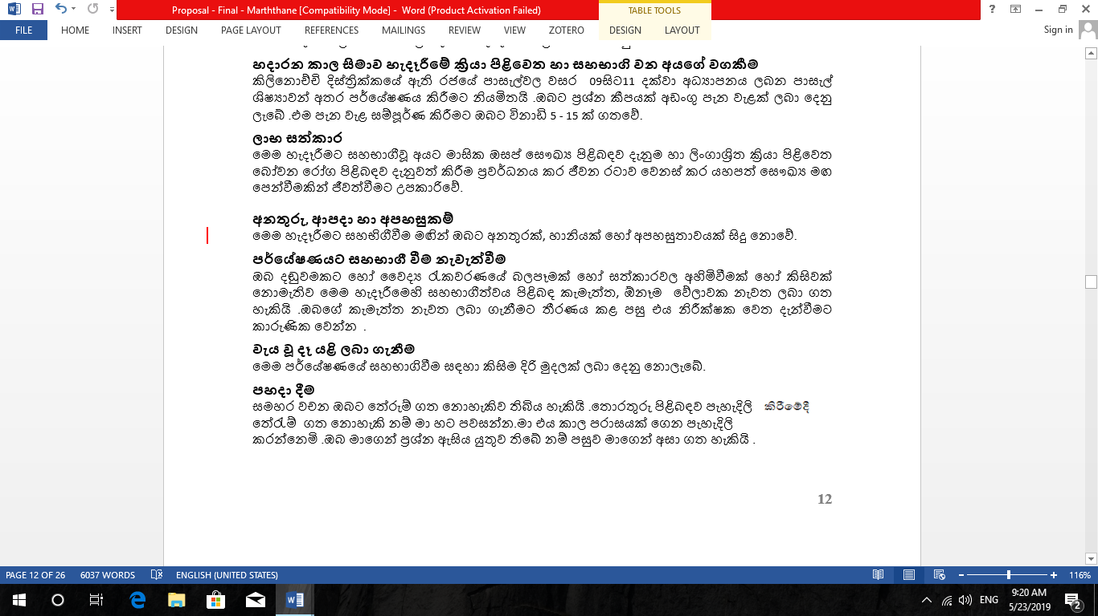
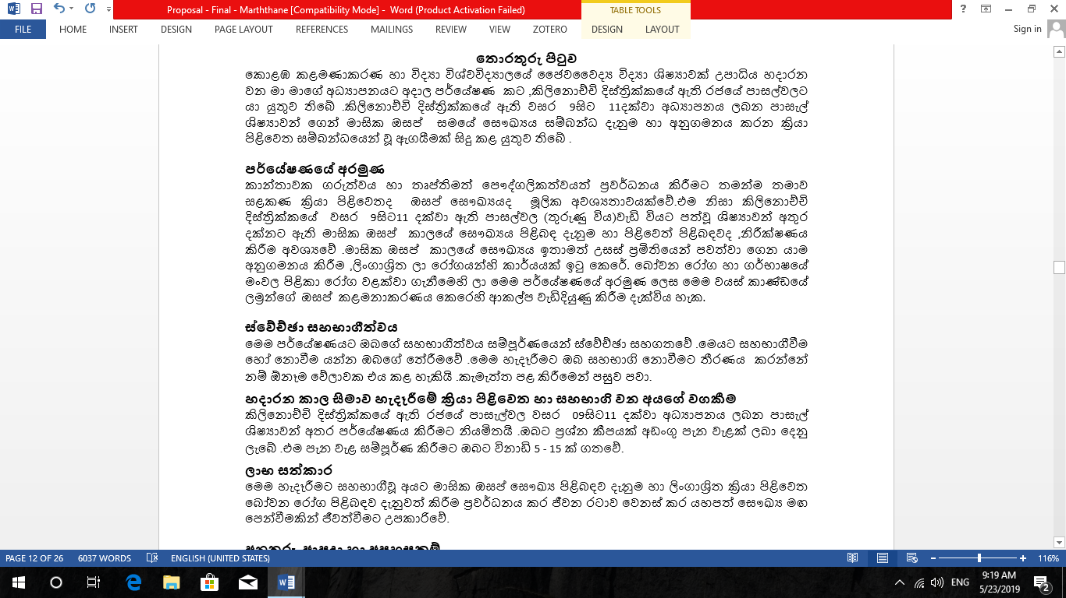
ANNEXURE Ⅲ
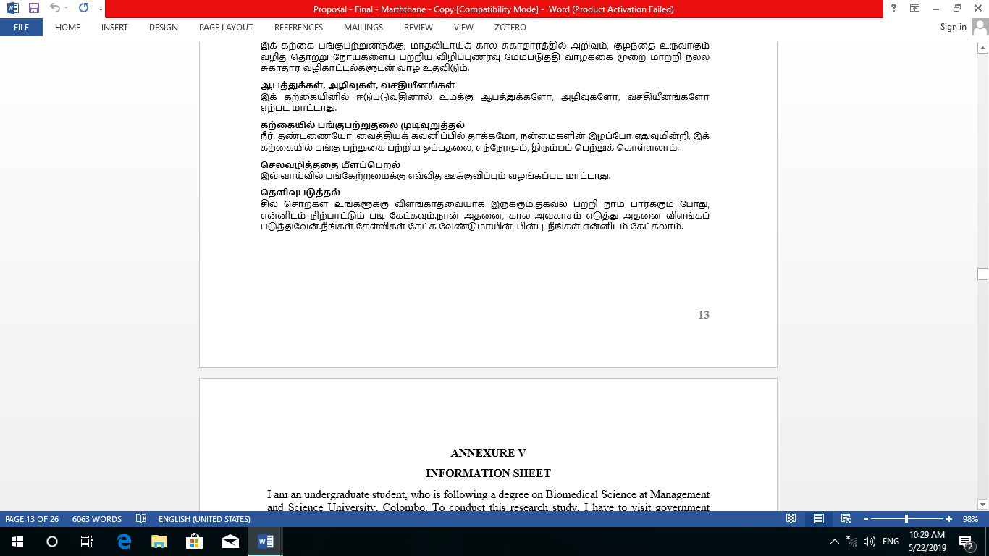
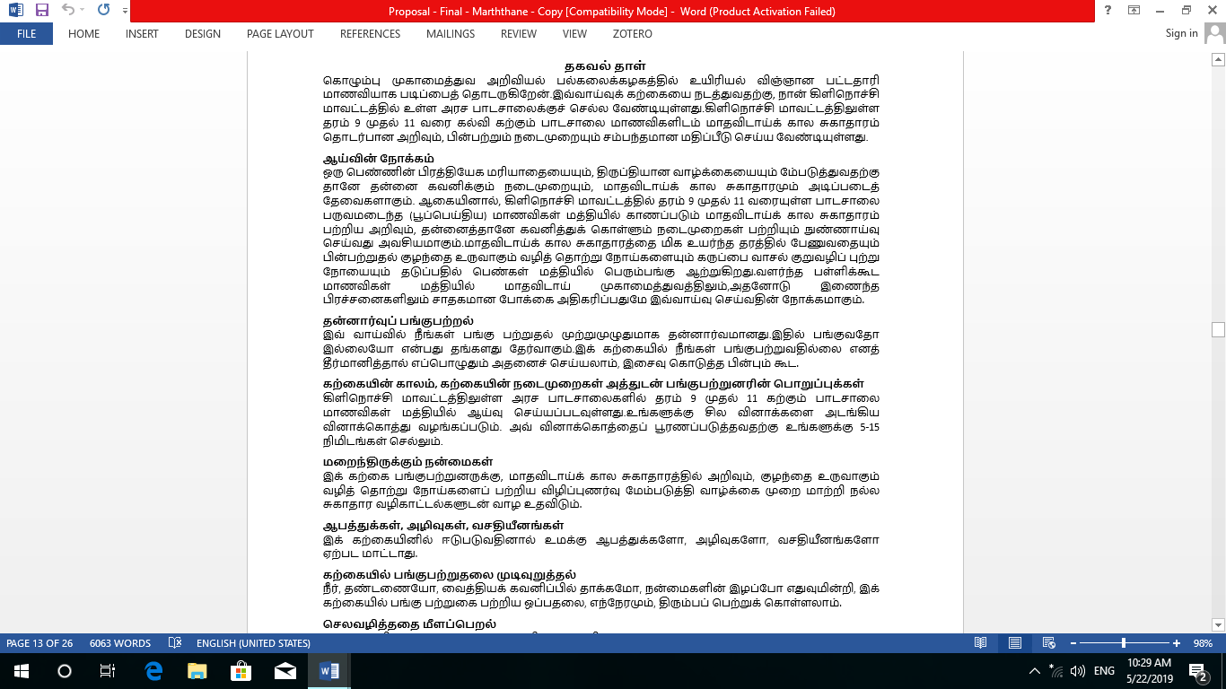
ANNEXURE Ⅳ

ANNEXURE Ⅴ
INFORMATION SHEET
I am an undergraduate student, who is following a degree on Biomedical Science at Management and Science University, Colombo. To conduct this research study, I have to visit government schools in Kilinochchi district and obtain necessary data to survey of level of knowledge and practices regarding Menstrual Hygiene among grade 9 to grade 11 school girls in Kilinochchi District.
Purpose of the Research
Self-care practices as well as menstrual hygiene are basic requirements for promoting a satisfied life and personal esteem in a woman. Therefore, it is necessary to investigate the knowledge and self-care practices of menstrual hygiene among grade 9 to grade 11 school girls who have attained menarche in Kilinochchi District. Adoption of high quality menstrual hygiene plays an important role in the prevention of Reproductive Tract Infections (RTI) and Cancer of cervix among the women population. The purpose of doing this research is to promote positive attitudes towards management of menstruation and related problems among the adolescent school girls.
Voluntary Participation
Your participation in this research is entirely voluntary. It is your choice whether to participate or not. If you decide not to participate for the study, you may do at any time even after giving consent.
Time of study, procedures of the study and participants responsibilities
The study will be carried out among grade 9 to grade 11 school girls from government schools in Kilinochchi district. You will be given some questions using a questionnaire, it will take 5-15 minutes for you to complete the questionnaire.
Potential benefits
This study will help participants to get a general idea regarding knowledge and practices on menstrual hygiene and to improve awareness of RTI and change their life style to good health directions.
Risks, hazards and discomforts
There will be no risks, hazards and discomforts for you by attending this study.
Termination of the study participation
You may withdraw your consent to participate in this study at any time, with no penalty or effect on medical care or loss of benefits. Please notify the investigator as soon as you decide to withdraw your consent.
Reimbursements
You will not be provided any incentive to take part in the research.
Clarification
There may be some words that you do not understand. Please ask me to stop as we go through the information and I will take time to explain. If you have questions later, you can ask them from me.

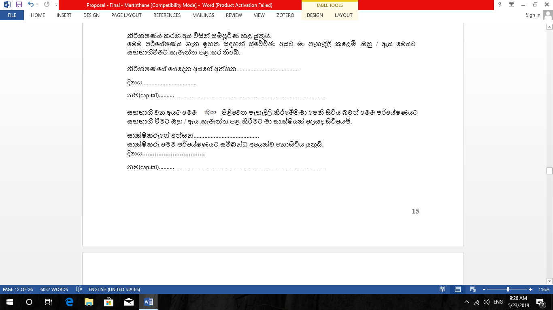
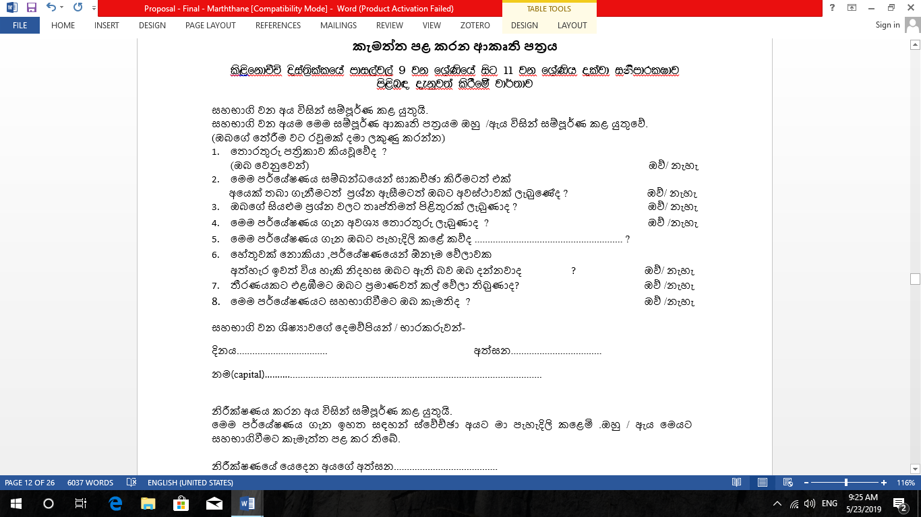
ANNEXURE Ⅵ
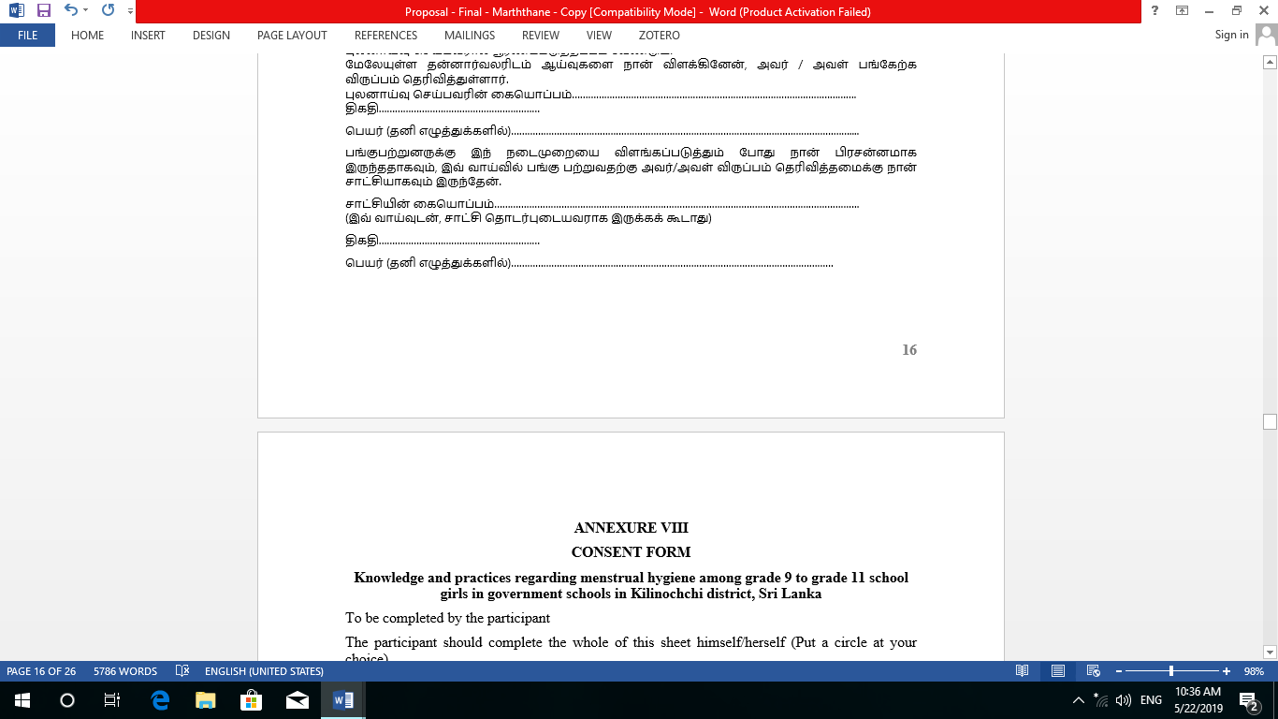
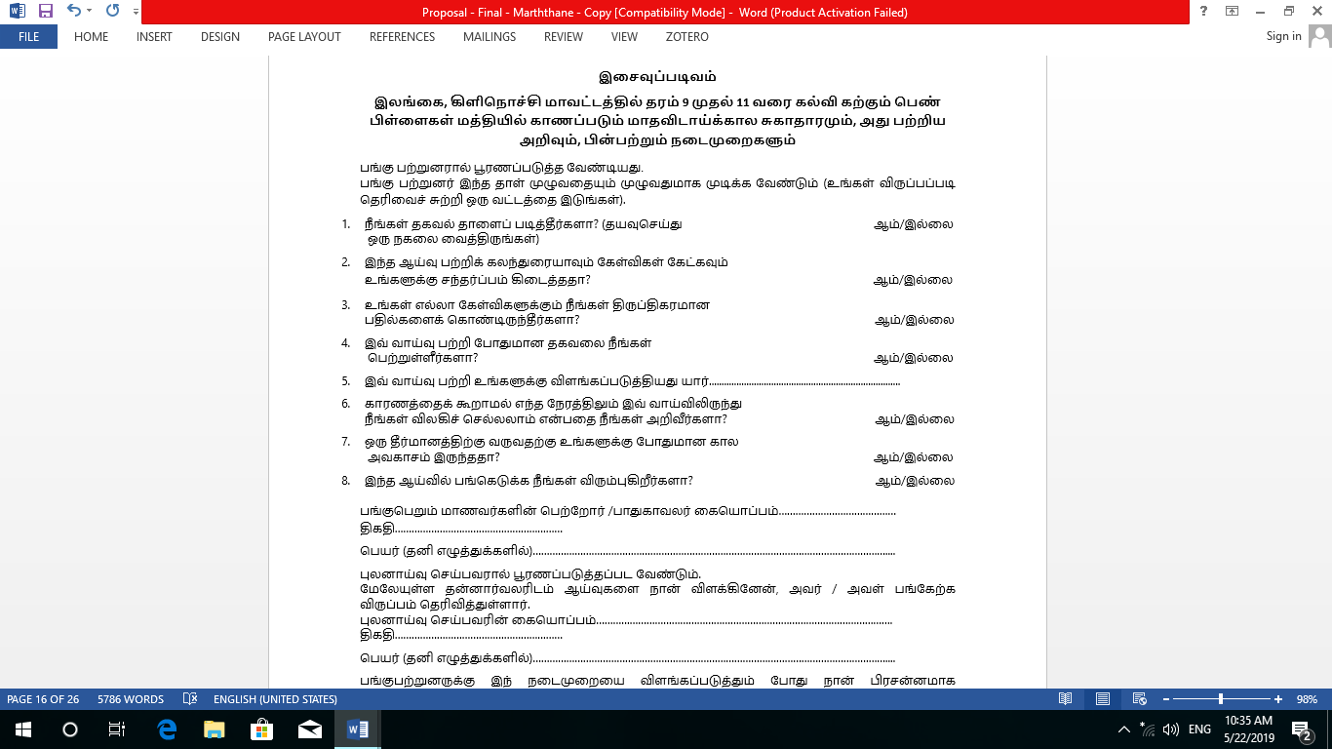
ANNEXUREⅦ
ANNEXURE Ⅷ
CONSENT FORM
Knowledge and practices regarding menstrual hygiene among grade 9 to grade 11 school girls in government schools in Kilinochchi district, Sri Lanka
To be completed by the participant
The participant should complete the whole of this sheet himself/herself (Put a circle at your choice).
- Have you read the information sheet? (Please keep a copy for yourself) YES/ NO
- Have you had an opportunity to discuss this study and ask any questions? YES/ NO
- Have you had satisfactory answers to all your questions? YES/ NO
- Have you received enough information about the study? YES/ NO
- Who explained the study to you? ………………………………………...
- Do you understand that you are free to withdraw from the study at any time, without giving a reason? YES/ NO
- Have you had sufficient time to come into a decision? YES/ NO
- Do you agree to take part in this study? YES/ NO
Participate student parents / guardian signature……………………………
Date ……………..................
Name (BLOCK CAPITALS) …………………………………………………………………..
To be completed by the investigator I have explained the study to the above volunteer and he/ she has indicated her willingness to take part.
Signature of the investigator ……………………………….
Date ………………………..
Name (BLOCK CAPITALS) ………………………………………………………………………
I have been present while the procedure has been explained to the participant and I have witnessed his/her consent to take part in the study.
Signature of witness …………………………………………
(The witness should be person NOT connected with the study)
Date…………………………
Name (BLOCK CAPITALS) ……………………………………………………………

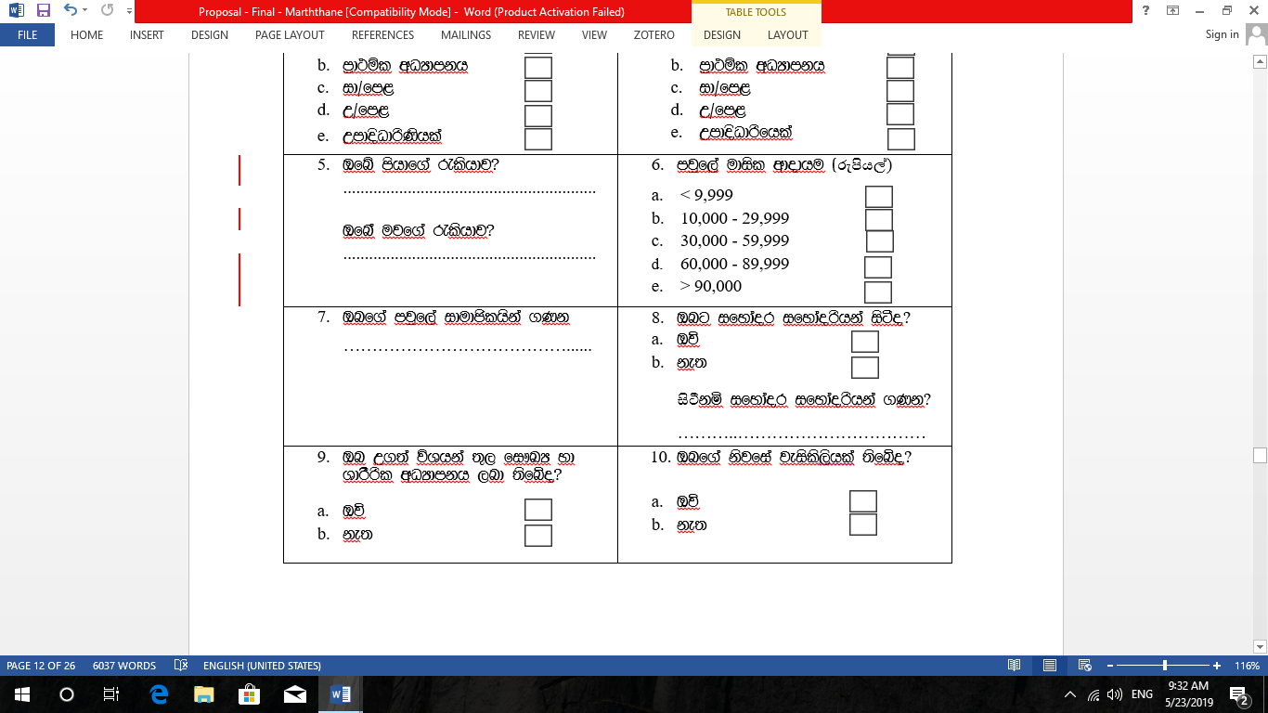
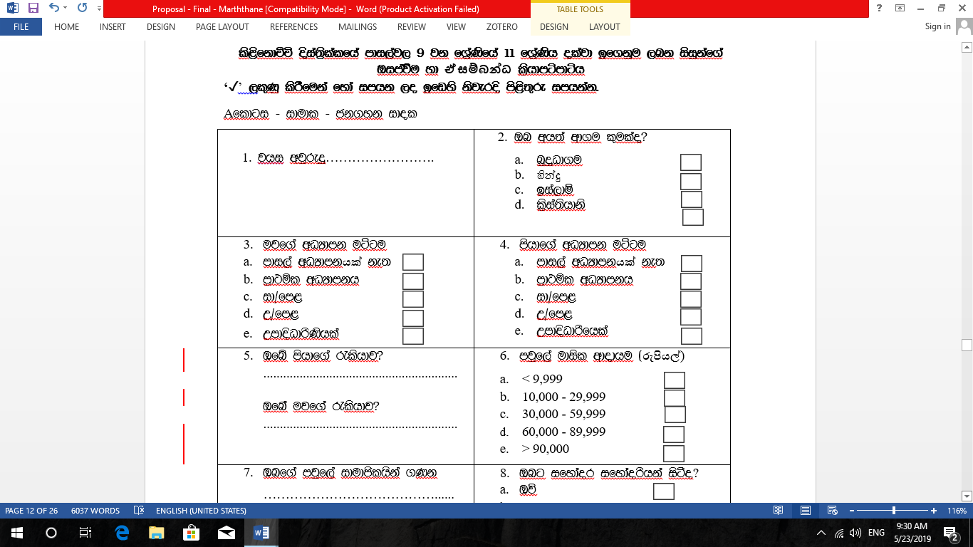
ANNEXURE Ⅸ
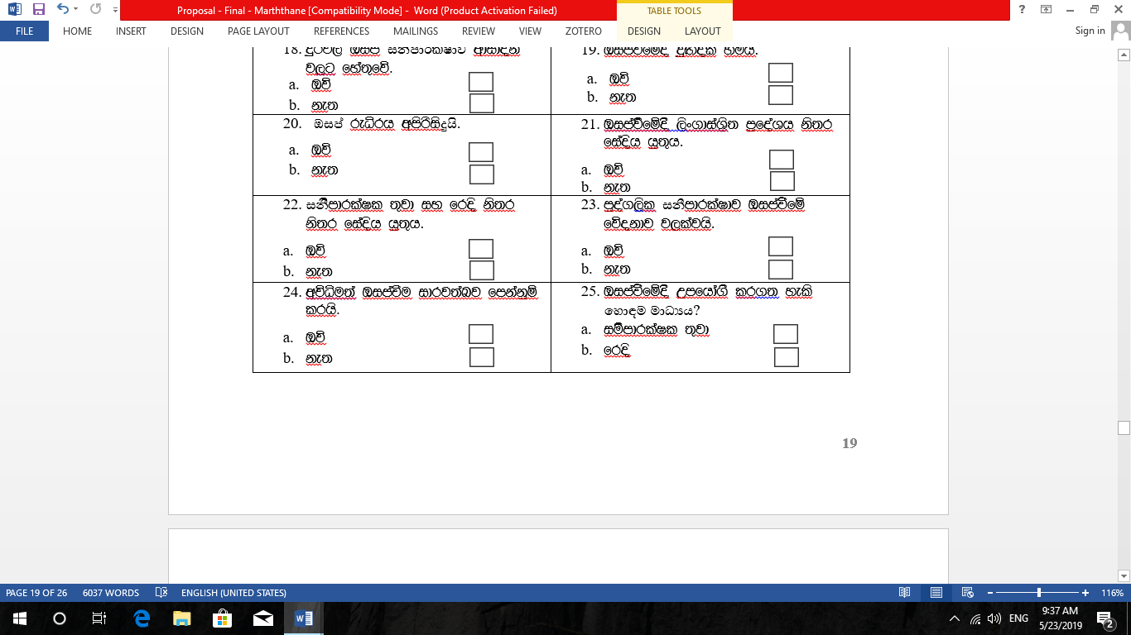
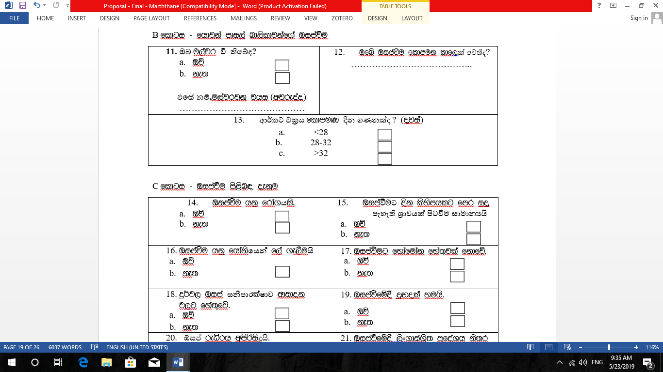
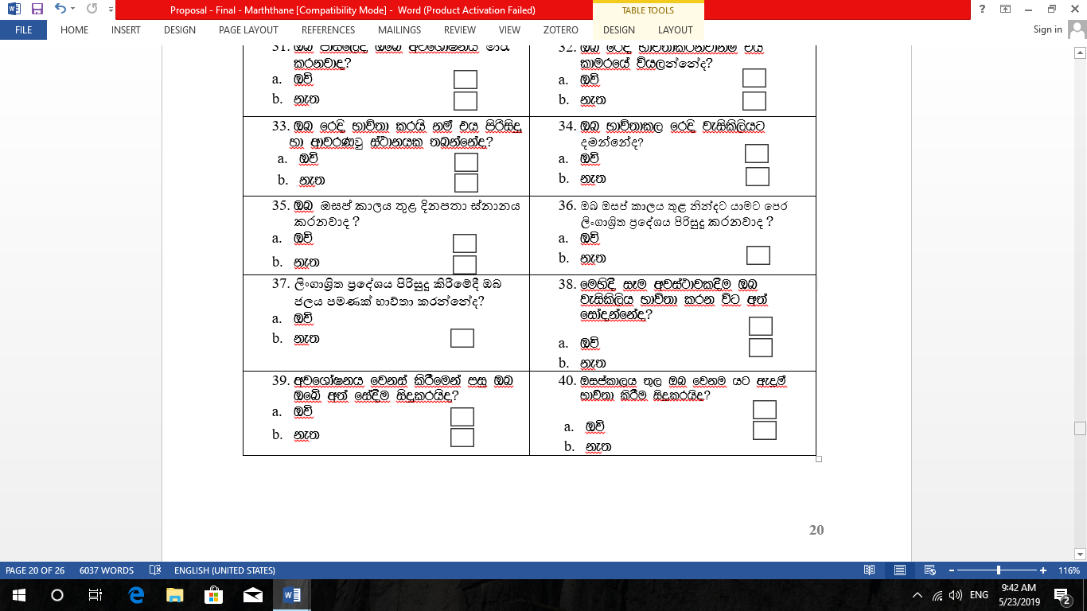
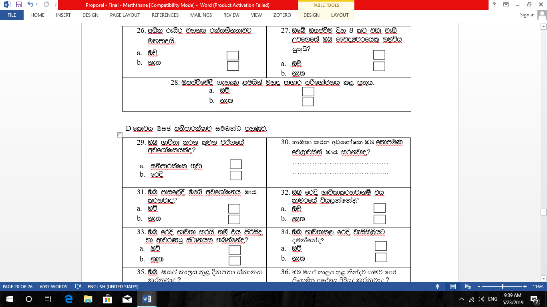

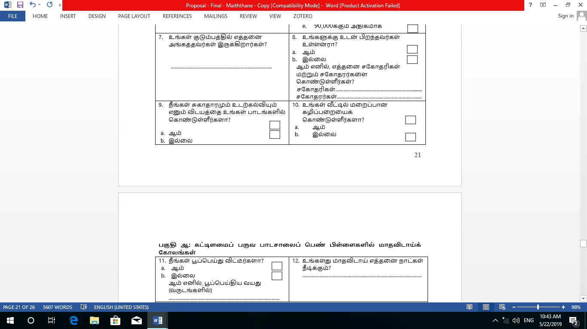
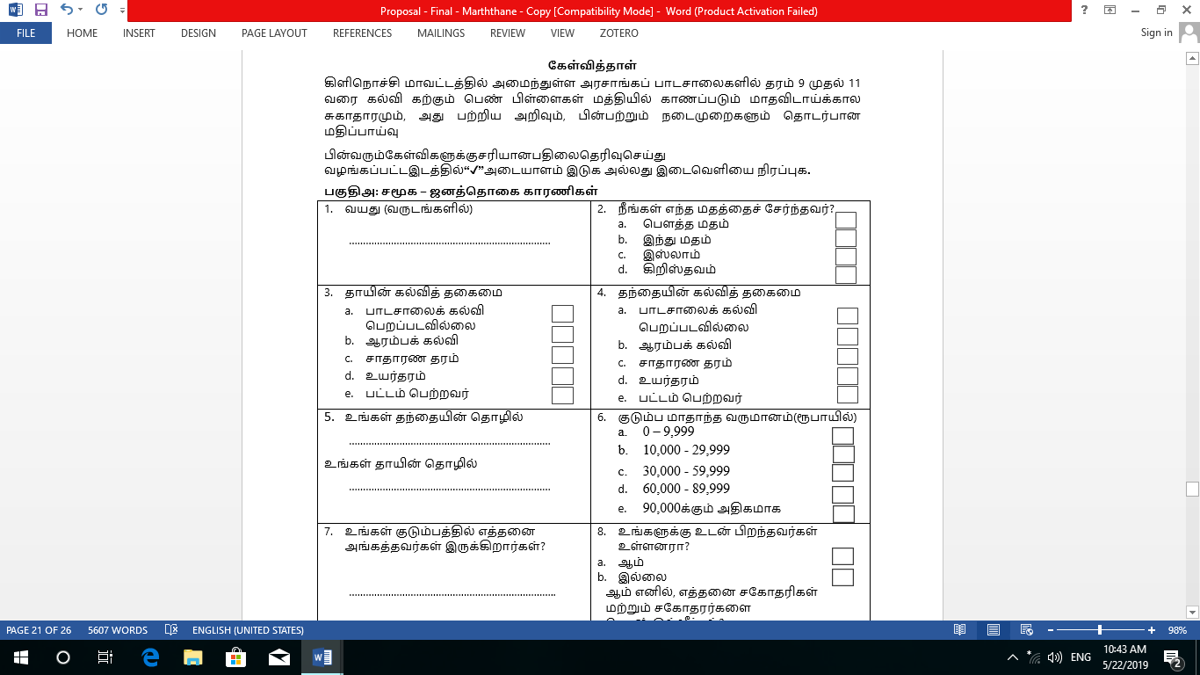
ANNEXURE Ⅹ

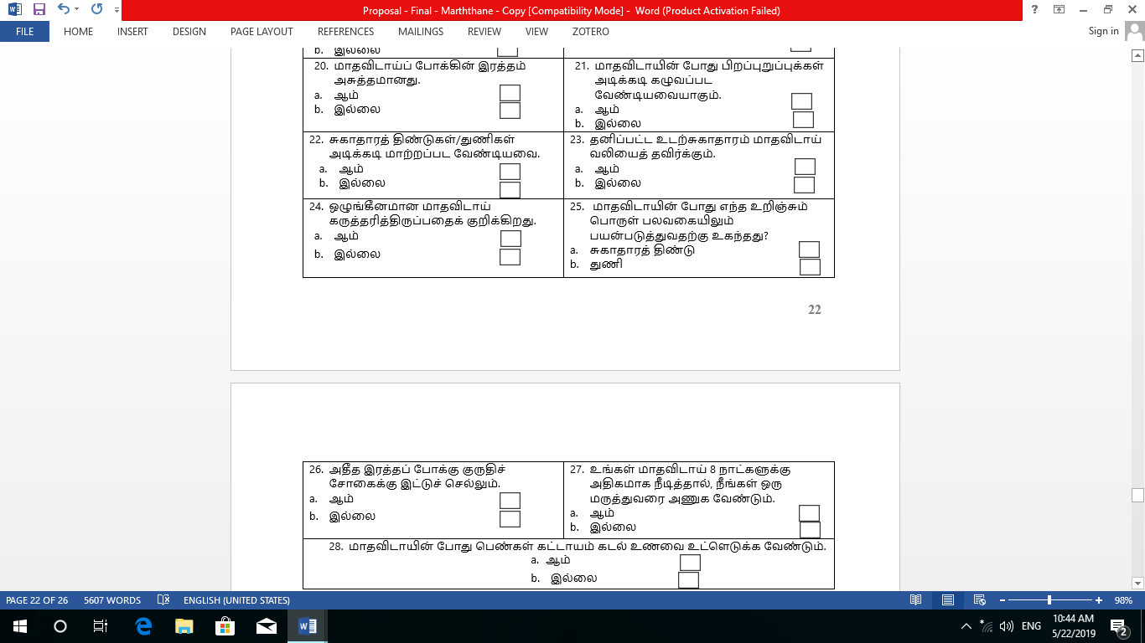
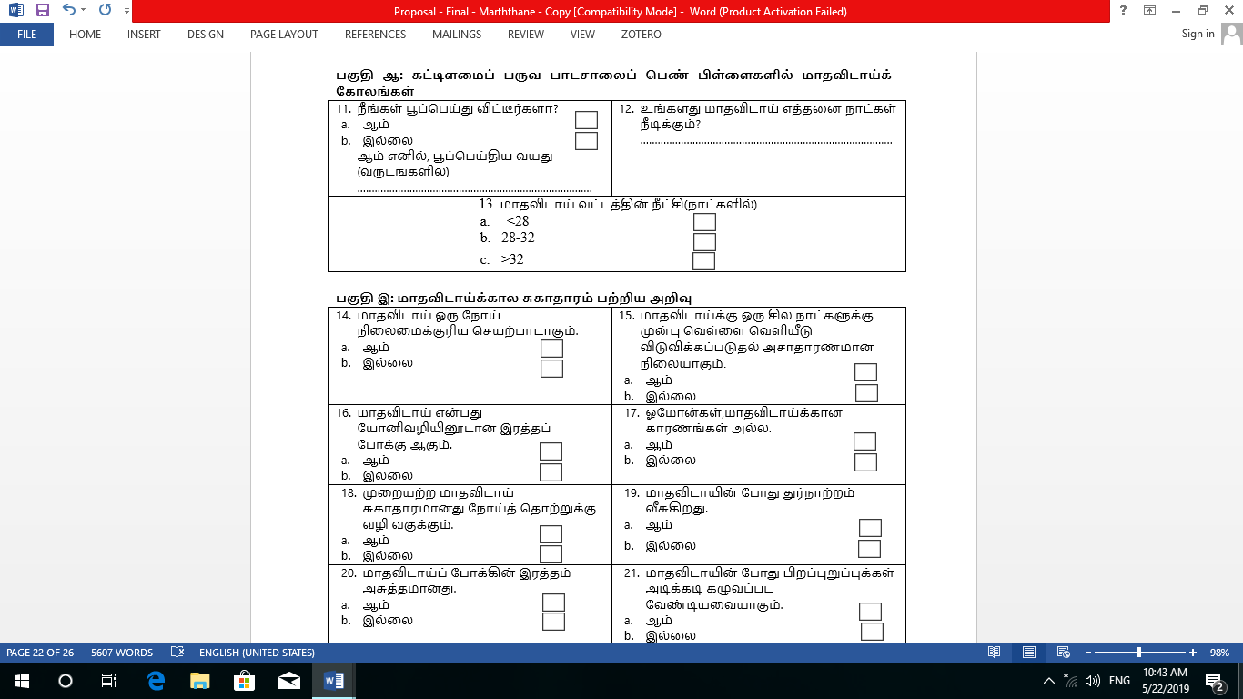
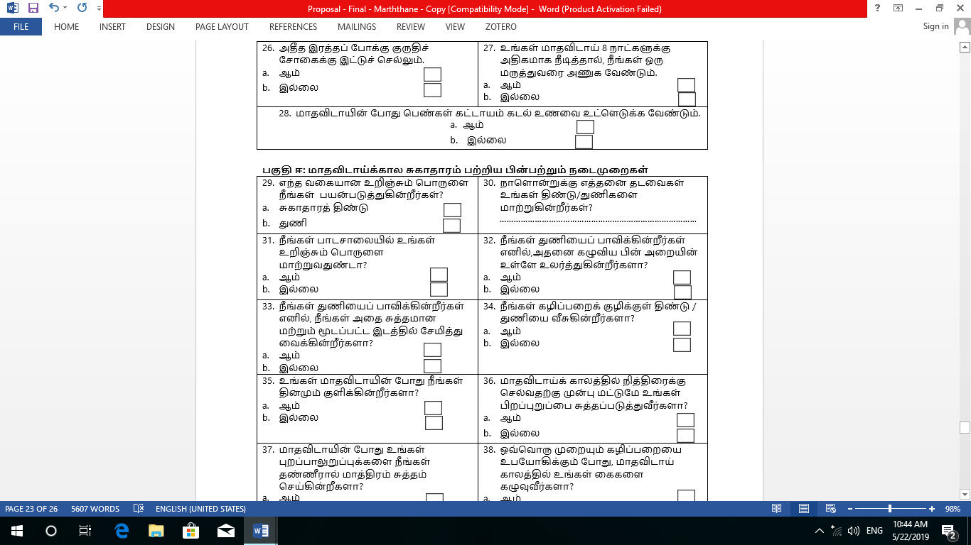
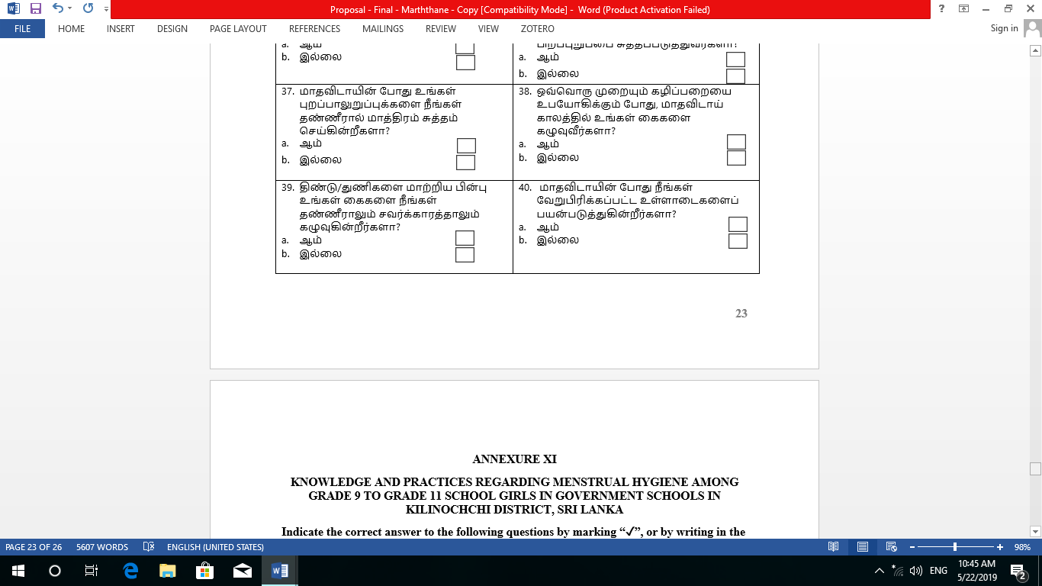

ANNEXURE Ⅺ
KNOWLEDGE AND PRACTICES REGARDING MENSTRUAL HYGIENE AMONG GRADE 9 TO GRADE 11 SCHOOL GIRLS IN GOVERNMENT SCHOOLS IN KILINOCHCHI DISTRICT, SRI LANKA
Indicate the correct answer to the following questions by marking “✓”, or by writing in the space provided.
Section A: socio-demographic factors
- Age in years………………………. | - Which religion do you belong to?  - Buddhism  - Hinduism  - Islam  - Christianity
  - Education level of Mother  - No-schooling    - Primary education    - O/L    - A/L    - Degree holder | - Education level of father      - No-schooling  - Primary education      - O/L    - A/L  - Degree holder
- What is your father’s occupation?  ………………………………………  What is your mother’s occupation?  ............................................................ |       - Family monthly income (in Rupees)    - 0 – 9,999  - 10,000 - 29,999    - 30,000 - 59,999  - 60,000 - 89,999  - >90,000
- How many members are there in your family?  ……………………………………… |   - Do you have siblings?    - Yes  - No  If yes, how many sisters and brothers do you have?  sisters…………………………………  brothers …………………………........
- Do you have health and physical education in your subjects?    - Yes    - No |   - Do you have a covered toilet in your house?  - Yes    - No

Section B: menstrual pattern in adolescent school girls
- Have you attained menarche?    - Yes    - No  If yes, age at menarche(yrs)  ….…………………………………… | - How many days does your period last?…………………………………
- Length of cycle(days)

- <28

- 28-32

- >32

Section C: Menstrual hygiene knowledge
- Menstruation is a disease process.    - Yes    - No |   - Release of a white discharge a few days before menstruation is abnormal.  - Yes    - No
- Menstruation is bleeding from vagina.    - Yes    - No |   - Hormones are not the cause of menstruation.    - Yes  - No
  - Poor menstrual hygiene predisposes to infection.    - Yes  - No |   - There is foul smell during menstruation.  - Yes    - No
  - Menstrual blood is unhygienic.    - Yes  - No |   - Genitalia should be washed frequently during menstruation.    - Yes  - No
- Pad/cloths should be changed frequently.    - Yes    - No |   - Personal hygiene prevents menstrual pain.    - Yes  - No
  - Irregular menstruation is an indication of fertility.    - Yes  - No | - Which absorbent should ideally be used during menstruation?    - Sanitary pads    - A cloth
  - Excessive bleeding leads to anemia.  - Yes    - No | - If your menstruation last for more than 8 days, you should see a doctor.    - Yes    - No
- During menstruation,girls must consume sea food.

- Yes

- No

Session D: Practices related to menstrual hygiene
  - Which type of absorbent are you using?    - Sanitary pads  - A Cloth | - How frequent are you changing your pad/cloths per day?  ……………………………………..
  - Do you change your absorbent in school?  - Yes    - No |   - If you are using cloth, do you dry it inside the room?  - Yes    - No
- If you are using cloth, do you store it in a clean and covered place?    - Yes    - No | - Do you throw pad/cloth in to the latrine?    - Yes    - No
  - Do you bathe daily during your menstruation?    - Yes  - No | - Before going to sleep do you clean your genitalia during menstruation?    - Yes    - No
- Do you clean your genitalia only with water during menstruation?    - Yes    - No |   - Every time while using toilet do you wash your hands during menstruation?  - Yes    - No
  - Do you wash your hands with water and soap after changing absorbents?  - Yes    - No | - Do you use separate undergarments during menstruation?    - Yes    - No

